Rarefied gas flow in pressure and vacuum measurements

Jeerasak Pitakarnnop1, Rugkanawan Wongpitayadisai1

1 National Institute of Metrology, Prathumthani, Thailand

ABSTRACT

Flows of a gas through piston-cylinder gap of a gas-operated pressure balance and in general vacuum system have one similar aspect, i.e., the gas is rarefied due to small passage and low pressure, respectively. The flows in both systems could characterize in either slip flow regime or transition regime. Therefore, fundamental researches of flow in these regimes are useful for both pressure and vacuum metrology, especially for the gas-operated pressure balance where continuum viscous flow model is widely used for determining an effective area of pressure balance. The consideration of gas flow using suitable assumption would improve the accuracy of such calculation. Moreover, knowledge in rarefied gas flow contributes a predictability of gas behaviors in vacuum and low-flow leak detection system. This paper provides useful information of rarefied gas flow in both slip flow and transition regimes.

**Keywords:** Rarefied Gas; Slip Flow; Kinetic Theory

**Citation:**

**Editor:**

**Received** month day, year; **In final form** month day, year; **Published** month day, year

**Copyright:** © 2012 IMEKO. This is an open-access article distributed under the terms of the Creative Commons Attribution 3.0 License, which permits unrestricted use, distribution, and reproduction in any medium, provided the original author and source are credited

**Funding:**

**Corresponding author:** Jeerasak Pitakarnnop, e-mail: Jeerasak@nimt.or.th

1. Introduction



Figure 1. Classification of gas flow regime.

Characteristic scale, *L*C, and pressure, *p*, are two main factors to characterize a flow regime in gas-operated system. Micro-scale gap between piston and cylinder of the pressure balance and ultra low pressure in the vacuum system could reduce large number of gas molecules and cause the gas to be rarefied. In consequence, due to small amount of gas molecules, flow behaviors are different from general gas where an amount of gas molecules is large enough to consider the gas as a continuum media. Therefore, the continuum media assumption is not valid for the aforementioned cases if the flows behave as slip, transition or free molecular flow. Regime of flow is characterized according to Knudsen number:

|  |  |
| --- | --- |
|  | (1) |

where *λ* is the molecular mean free path and *L*C, is the characteristic scale of the gas flow. Regarding the value of Knudsen number, 4 regimes could be distinguished as shown in Figure 1. When Kn is very small, there are enough gas molecules to be considered as a gas in continuum regime. Slip flow and other effects, such as temperature jump at a solid surface, start to appear at Kn more than 0.001 and is dominant around 0.01, whereas slip flow regime begins. When gas is more and more rarefied, gas flow will characterize in transition regime and in free molecular regime when Kn reaches 0.1 and 10, respectively. To precisely predict gas behaviors, it is compulsory to know regime of flow. Using wrong assumptions could lead to an enormous error.

Apart from Knudsen number, rarefaction factor and another quantities, which are also used to describe flow regime, could be defined as

|  |  |
| --- | --- |
|  | (2) |

The molecular mean free path could not be directly measured. In this paper, it is determined basing on Maxwell theory as:

|  |  |
| --- | --- |
|  | (3) |

where *μ* is the viscosity at temperature *T* and $\tilde{v}=\sqrt{2 R T}$ $\tilde{v}=\sqrt{2RT}$ is the most probable molecular velocity. From above equation, Knudsen number as a function of pressure of gas, which flow through piston-cylinder gap in gauge mode, in absolute mode, and through ISO-standard tube, is plotted in Figure 2.

According to Figure 1, in absolute pressure operation of the pressure balance (dash line), flows through piston-cylinder gap of 0.3 μm, 0.6 μm, and 0.9 μm are in transition and molecular flow regime. Even in gauge mode (strong solid line), gas is rarefied enough to characterize in either slip or transition regime. Dadson’s theory [1], which bases on continuum flow assumption, would be inappropriate to solve for the effective area of a piston-cylinder assembly under these conditions. Therefore, Dadson’s theory has been modified to provide more accurate results [2][3][4]. This paper proposes an alternative method, especially in slip flow regime where continuum assumptions are still valid with special consideration at the solid surface. This method, which slip boundary is applied at the surface, is useful for a simulation of flow through piston-cylinder gap in commercial CFD software.

Flow in vacuum system could be in any regime from continuum to molecular flow depending on pressure and dimensions of gas container and passage. For conventional ISO tube (solid line), rarefied gas effects rise up when pressure is less than 1000 Pa. At this point, conventional continuum theory begins to break. Therefore, Navier-Stokes equations are no longer valid.

The objective of this paper is to demonstrate results of slip flow models and kinetic BGK (Bhatnagar-Gross-Krook) model in both slip flow and transition regimes, the regimes that we are mostly facing in pressure and vacuum metrologies. Slip flow equations, which extend the validity of Navier-Stokes model, are pointed out. The equations are rigorously validated for microchannels [7]. The presented models are less complicate than kinetic models, however provides quite accurate results in slip flow regimes.

1. SLIP FLOW

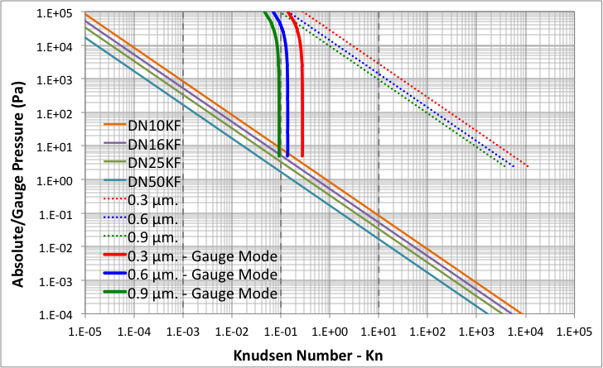

Figure 2. Kn as a function of pressure for N2 at 20°C

The slip flow regime is a slightly rarefied regime, which could occur in gas flows through the piston-cylinder gap and the vacuum systems as shown in Figure 2. It typically corresponds to a Knudsen number ranging between 10-2 and 10-1, which is easily reached for a flow through micrometer-scale gap in standard conditions of pressure balance operating in gauge mode or in rough vacuum. The Knudsen layer plays a fundamental role in the slip flow regime. This thin layer, one or two molecular mean free paths in thickness, is a region of local non-equilibrium, which is observed in any gas flow near a surface. In non-rarefied flow, the Knudsen layer is too thin to have any significant influence, but in the slip flow regime, it should be taken into account. [5]

Although the Navier-Stokes equations are not valid in the Knudsen layer, due to a nonlinear stress/strain-rate behaviour in this small layer [6], their uses with appropriate boundary velocity slip and temperature jump conditions, provided an accurate prediction of mass flow rates [7]. The slip flow condition was firstly proposed by Maxwell and has been developed to the second order later on. Several models have been proposed. Most of them are in the same forms but slightly different in coefficients. If isothermal flow is assumed, the slip flow models could be derived in general second order form as:

|  |  |
| --- | --- |
|  | (4) |

where *uslip* is the slip velocity, *us* is the flow velocity at the wall and *uw* is the velocity of the wall and its normal direction noted as *n*. The mean free path of the molecules is *λ* and *α* is the tangential momentum accommodation coefficient, equal to unity for perfect diffuse molecular reflection and zero for purely specular reflection. *Aα* and *Aβ* are the first and second order dimensionless coefficients, respectively. In Maxwell’s model, *Aα* was taken equal to unity, which, however, overestimates the real velocity at the wall but leads to rather good prediction of velocity of gas outside Knudsen layer. Examples of *Aα* and *Aβ* proposed in the literatures are shown in Table 1.

Table 1. Overview of styles and font sizes used in this template.

|  |  |  |
| --- | --- | --- |
| Author, Year | *Aα* | *Aβ* |
| Maxwell, 1879  Cercignani, 1964  Deissler, 1964  Hadjiconstantinou, 2003 | 1  1.1466  1  1.1466 | -  0.9756  9/8  0.647 |

To determine pressure distribution along piston and cylinder surfaces or flow through vacuum system, the boundary equation (4) is applied to Navier-Stokes equations. The equations could be solved analytically for a flow through simple geometry, whereas flow inside more complicated model requires a numerical calculation. Normally, commercial CFD (Computational Fluid Dynamics) software such as ANSYS FLUENT provides possibilities to input slip boundary conditions at a boundary surface. Methods to apply the boundary conditions in CFD software has been presented in the literatures [5][8].

The flow through piston-cylinder gap is considered as a flow through two infinite parallel plates (or slab) in the analysis, due to the gap between piston and cylinder of the pressure balance is very small compared to the radius of piston. After applying slip coefficient to Navier-Stokes equations, reduced flow rate for slab flow is derived in terms of rarefaction parameter as:

|  |  |
| --- | --- |
|  | (5) |

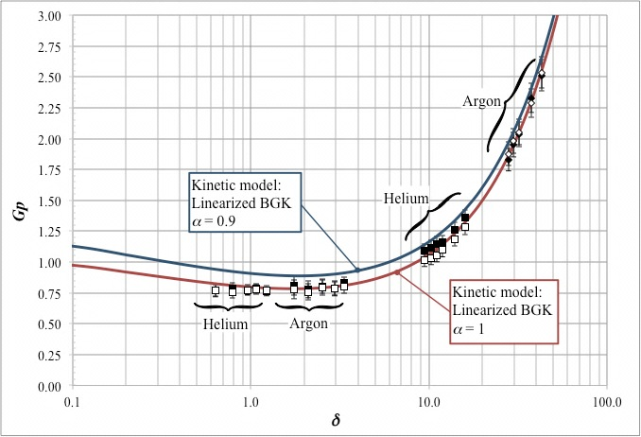

Figure 3. Reduced flow rate (*Gp*) versus Rarefaction parameter (*δ*) of flow through rectangular channel (aspect ratio ≈ 0.1)[7**]**.

Since rarefaction parameter in equation (5) depends on pressure, hence, reduced flow rate, *G*p and pressure distribution along the slab should be computed, iteratively. The equation of pressure distribution along piston and cylinder was derived by Priruenrom [9] as

|  |  |
| --- | --- |
|  | (6) |

where *p*1 is the applied pressure at the bottom of piston, *p*2 is the pressure above the piston, *z* is the axial coordinate along piston and cylinder and *l* is the piston-cylinder overlapped length. Further information of how to determine an effective area and a pressure distortion coefficient using above equation is presented in her thesis.

Furthermore, slip flow methods previously discussed could be employed to predict gas flow through a vacuum piping system. The only difference is a cross-sectional geometry of flow passage, which is normally circle. The reduced flow rate for slip flow through tube is defined

|  |  |
| --- | --- |
|  | (7) |

A flow parameter that most applications are focused on is mass flow rate through the passage. It could be calculated from reduced flow rate as follows [10][11]:

For the slab flow,

|  |  |
| --- | --- |
|  | (8) |

where *A* is the cross section area of the channel, *H* is the height of the slab.

For the flow through circular tube,

|  |  |
| --- | --- |
|  | (9) |

where *R* is the radius of the tube.

1. transition flow

As discussed in the previous section, slip flow models are limited within slip flow regime. It is compulsory to use kinetic theory of gas in transition regime. Solutions based on kinetic theory of gases are valid in whole range of the Knudsen number from the free molecular, through the transition up to the slip and hydrodynamic regimes. In this paper, the BGK, which is one of kinetic model, is chosen and the linearized BGK model is solved numerically by DVM (Discrete Velocity Method) to determine flow behaviors. Over the years, it has been shown that fully developed isothermal pressure driven flows, as ones investigated in previous research work [7], is predictable accurately by kinetic model e.g. the linearized BGK equation. Figure 3 shows a comparison between measurement results and those from BGK model.

The gas flow rate measurements were performed at the inlet () and the outlet (☐) of a series of rectangular microchannels whose aspect ratio is approximately around 0.1. The reduced flow rate, *G*p, is plotted in terms of the rarefaction parameter, *δ*. Measurement results are in good agreement with the kinetic model based on the linearized BGK equation, with *α* = 1. Investigation details are described in the literature.

1. results

Results of slip flow model for slab flow is shown in Figure 4, where the reduced flow rates, *G*p, from equation (5) for each model presented in Table 1 are plotted in terms of the rarefaction parameter, *δ*. To examine the study, the result from BGK model is plotted as a benchmark case. All results are in very good agreement in slip flow regime where *δ* > 8.86 (Kn < 0.1), except first order slip flow significantly deviates from the others near the upper limit of slip flow regime. Up to 8.5% difference is observed at *δ* = 9 when compared with the result from BGK method. Hadjiconstantinou equation yields the closest result to BGK method, less than 0.9% difference is observed for the entire slip flow regime.

An overall view from slip to molecular flow regime is shown in Figure 5. To focus on transition flow regime, the rarefaction parameter, *δ*, is plotted in logarithmic scale.

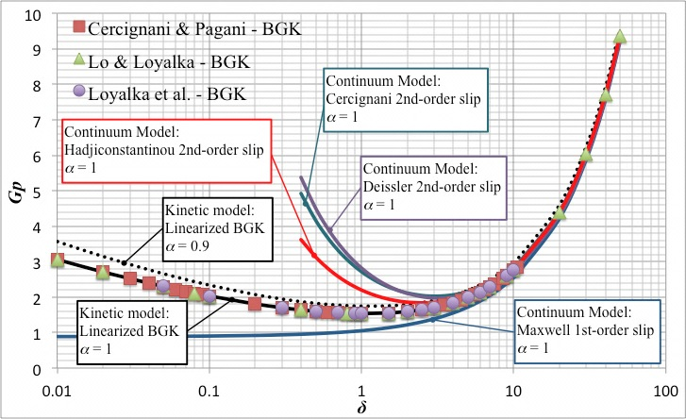

Figure 4. Reduced flow rate (*Gp*) versus Rarefaction parameter (*δ*) of flow through slab (*α*= 0.9,1).

The result of BGK model when the tangential accommodation (*α*) is equal to 0.9, is provided to observe a trend of the result when the gas-surface interaction is no longer considered as purely diffuse collision. Moreover, results of BGK model from Cercignani & Pagani () [12], Lo & loyalka (Δ) [13] and Loyalka et al. (o) [4] are demonstrated to ensure the study. The differences of the results between each BGK model are not significant through out the entire regimes, whereas the results from any slip flow models fail to predict rarefied gas flow in transition and molecular flow regimes.

In circular cross section, the trend of the results shown in Figure 6 is not much different from above case. The result from BGK model at *α* = 1 is in very good agreement with those of Cercignani & Sernagiotto () [15], Sharipov (Δ) and Loyalka & Hamoodi (o) using BGK model [16], Shakov model and Numerically-Solved Boltzmann Equation [17], respectively.

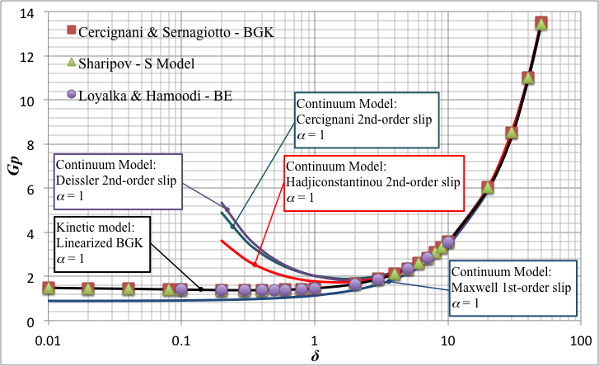

Figure 5. Reduced flow rate (*Gp*) versus Rarefaction parameter (*δ*) of flow through circular tube.

Similar to slab flow, all slip flow equations break down in transition and molecular flow regimes. However, in slip flow regime, the boundary equation in conjunction with Navier-Stokes equation is a preferable path to solve for bulk flow due to simpler calculation complexity and lower required resources. Especially for basic geometry, exact solution is solvable.

1. discussions and conclusion

General equations to determine flow rate of rarefied gas flow through slab and tube based on Navier-Stoke equations in conjunction with slip boundary conditions are acquired. Their results are compared with those from kinetic theory using BGK model. The slip flow models are analyzed and the results of BGK model are obtained by numerical method using DVM (Discrete Velocity Method) scheme. As a result, slip models require lower computational resources, however, their performance is limited. They provide a reliable result solely within continuum and slip flow regimes but fail to predict rarefied gas flow in both transition and molecular flow.

Since slip flow method is easier to handle and to apply in a commercial CFD (Computational Fluid Dynamic) software for solving complex problem, it is still a preferable method. It could be used as an alternative method to determine gas flow between piston-cylinder gap in slip flow regime. Moreover, such method also provide precise prediction of flow rate through piping system of the vacuum system operating in slip flow regime.

1. acknowledgment

Several years ago, Stéphane Colin, Lucien Baldas, Sandrine Geoffroy and the colleagues at INSAT opened a door to the world of rarefied gas dynamics to the first author with a great chance to join their researches. After few years, a chance to meet Prof. Dimitris Valougeorgis and the colleagues at University of Thessaly brought him a key to solve kinetic theory of gases. Their kind supports in knowledge and mind are always grateful for me.

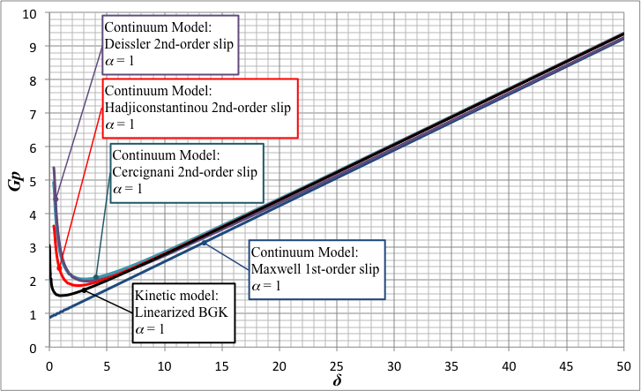

Figure 6. Reduced flow rate (*Gp*) versus Rarefaction parameter (*δ*) of flow through slab (*α*=1).

References

[1] R. S. Dadson, S. L. Lewis and G. N. Peggs, The pressure balance: Theory and practice. London, HMSO, 1982.

[2] C. M. Sutton, “The effective area of a pressure balance at low pressures,” J. Phys. E: Sci. Instrum., vol. 13, pp. 857-859, 1980.

[3] J. W. Schmidt, B. E. Welch, and C. D. Ehrlich, “Operational mode and gas species effects on rotational drag in pneumatic dead weight pressure gauges,” Meas. Sci. Technol., vol. 4, pp. 26-34, 1993.

[4] J. W. Schmidt, S. A. Tison, and C. D. Ehrlich, “Model for drag forces in the crevice of piston gauges in the viscous-flow and molecular flow regimes,” Metrologia, vol. 36, pp. 565-570, 1999.

[5] J. Pitakarnnop, S. Geoffroy, S. Colin and L. Baldas, “Slip flow in triangular and trapezoidal microchannels,” International Journal of Heat and Technology, vol. 26, no. 1 pp. 167-174, 2008.

[6] D. A. Lockerby, J. M. Reese, and M. A. Gallis, “Capturing the Knudsen layer in continuum-fluid models of nonequilibriun gas flows,” AIAA Journal, vol. 43, no. 6 pp. 1391-1393, 2005.

[7] J. Pitakarnnop, S. Varoutis, D. Valougeorgis, S. Geoffroy, L. Baldas and S. Colin, “A novel experimental setup for gas microflows,” Microfluid Nanofluid, vol. 8, no. 1 pp. 57-72, 2010.

[8] J. Pitakarnnop, Analyse expérimentale et simulation numérique d’écoulements raréfiés de gaz simple et de mélanges gazeux dans les microcanaux, Université de Toulouse, 2009.

[9] T. Priruenrom, Development of pressure balance for absolute pressure measurement in gases up to 7 MPa, Clausthal University of Technology, 2011.

[10] F. Sharipov and V. Seleznev, “Data on internal rarefied gas flows,” J. Phys. Chem. Ref. Data, vol. 27, no. 3 pp. 657-706, 1998.

[11] S. Varoutis et al, “Computational and experimental study of gas flows through long channels of various cross sections in the whole range of the Knudsen number,” J. Vac. Sci. Technol. A, vol. 27, no. 1 pp. 89-100, 2009.

[12] C. Cercignani and C. D. Pagani, “Variational approach to boundary-value problems in kinetic theory,” Phys. Fluids, vol. 9, no. 6, pp. 1167-1173, 1966.

[13] S. S. Lo and S. K. Loyalka, “An efficient computation of near-continuum rarefied gas flows,” J. Appl. Math. Phys. (ZAMP), vol. 33, no. 3 pp. 419-424, 1982.

[14] S. K. Loyalka, N. Petrellis and T. S. Storvick, “Some exact numerical results for the BGK model: Couette, Poiseuille and thermal creep flow between parallel plates,” J. Appl. Math. Phys. (ZAMP), vol. 30, no. 3 pp. 514-521, 1979.

[15] C. Cercignani and F. Sernagiotto, “Cylindrical Poiseuille flow of a rarefied gas,” Phys. Fluids, vol. 9, no. 1, pp. 40-44, 1966.

[16] F. Sharipov, “Rarefied gas flow through a long tube at any temperature ratio,” J. Vac. Sci. Technol. A, vol. 14, no. 4, pp. 2627-2635, 1996.

[17] C. Cercignani and S. A. Hamoodi, “Poiseuille flow of a rarefied gas in a cylindrical tube: solution of linearized Boltzmann equation,” Phys. Fluids, vol. 2, no. 11, pp. 2061-2065, 1990.