Author Queries
Authors of the paper:
Giuseppe Del Prete, Daniele Gallo, Carmine Landi, Mario Luiso
- The photo is out of focus. Provide a better image
Ans A new photo is provided
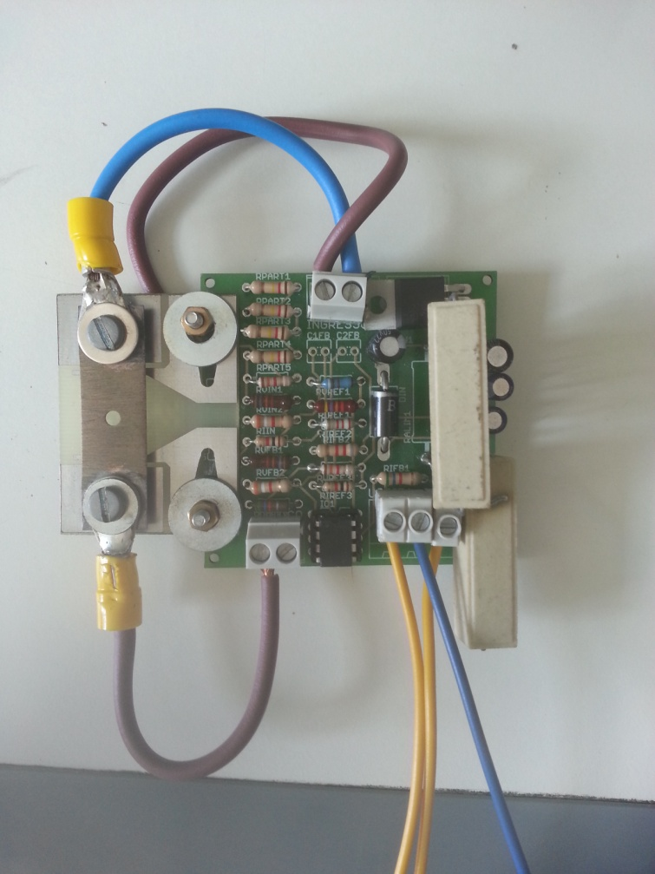

- The photo is out of focus. Provide a better image
Ans A new photo is provided
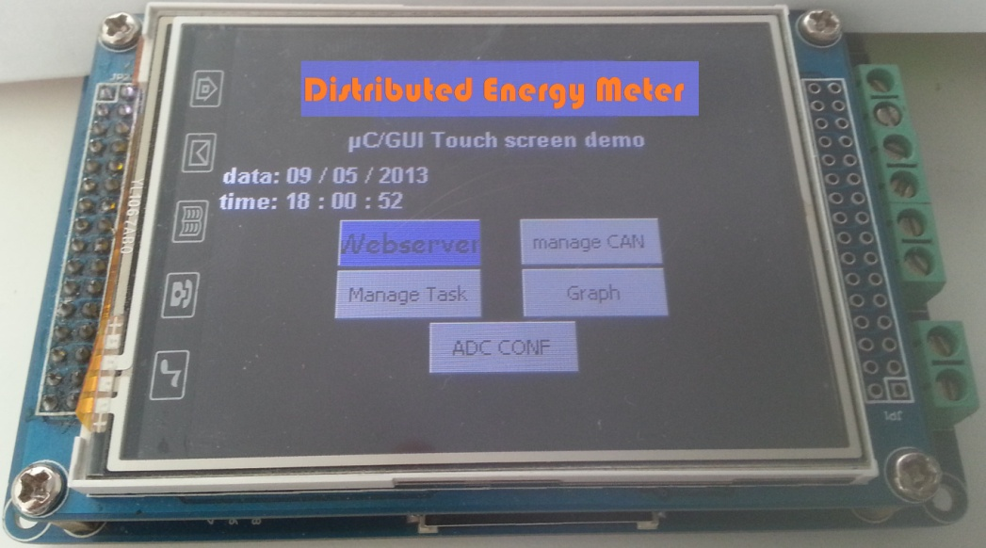

- The photo is out of focus. Provide a better image
Ans A new photo is provided
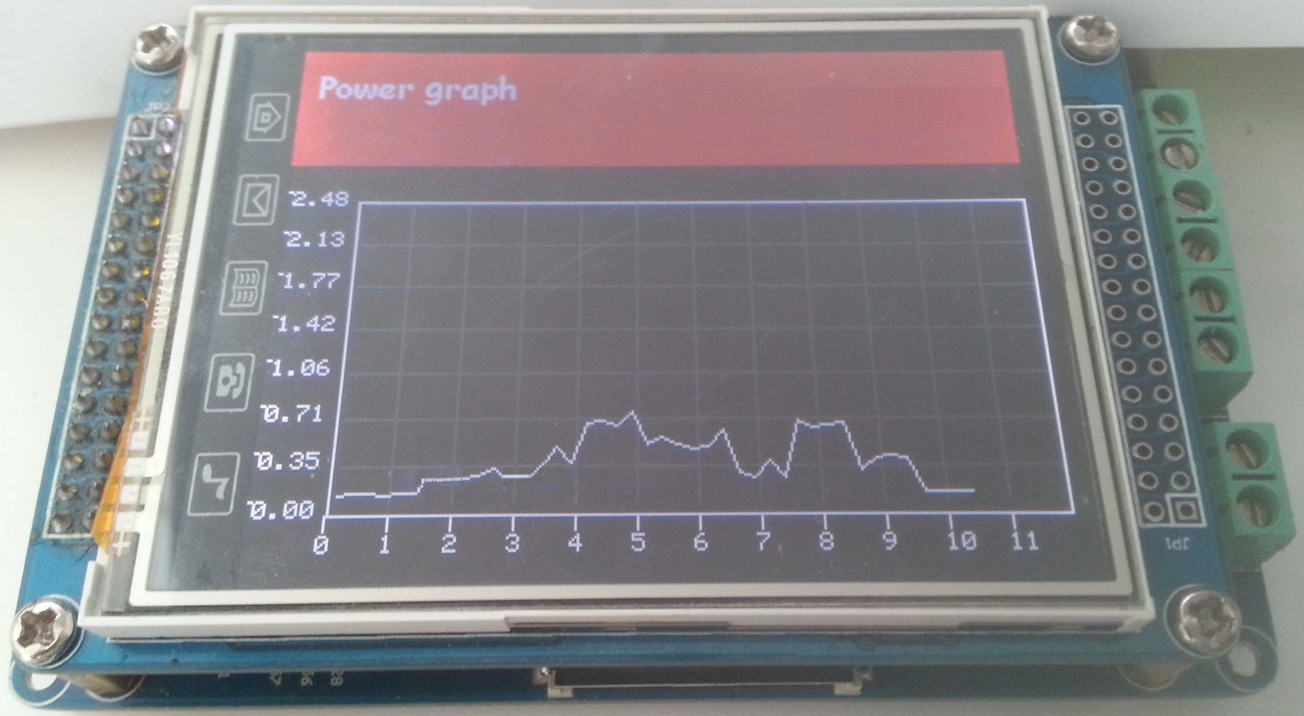

- Provide a higher resolution image. The text is hard to read
Ans The original image had poor resolution, so a new image is provided.
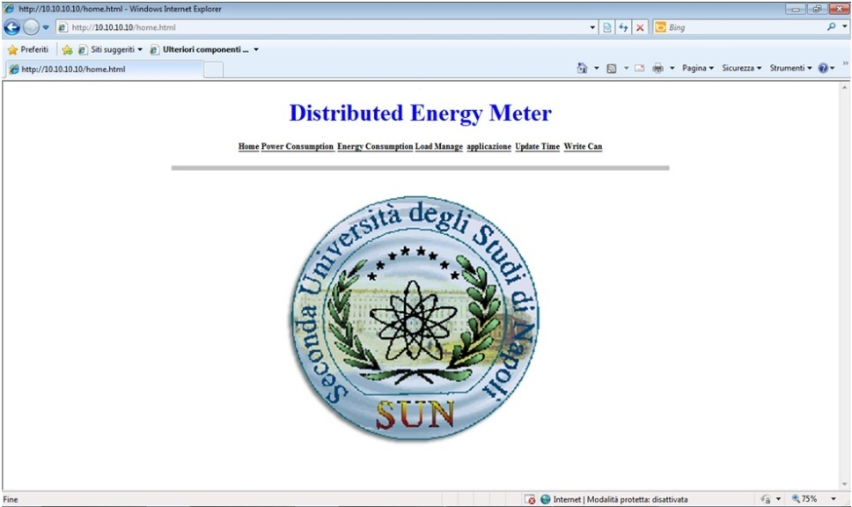

- Provide a higher resolution image. The text is hard to read
Ans A new image is provided
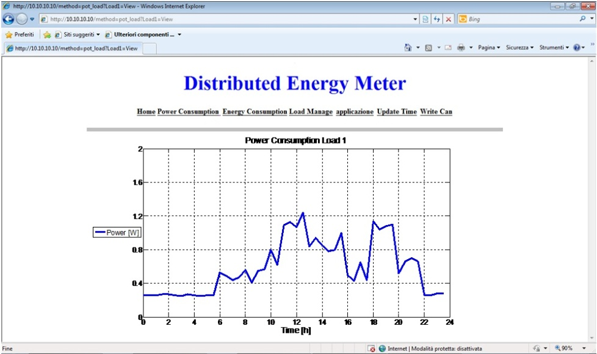
- Add bigger text labels on the axes. The current font size is too small
Ans A new image is provided
- Add bigger text labels on the axes. The current font size is too small
Ans A new image is provided
- Add bigger text labels on the axes. The current font size is too small
Ans A new image is provided
- Add bigger text labels on the axes. The current font size is too small
Ans A new image is provided
- Check and confirm the highlighted text substitution
Ans The text substitution is correct
- Check and confirm the highlighted text substitution
Ans The text substitution is correct
- Check and confirm the highlighted text substitution
Ans The text substitution is correct
- Provide city of publication and ISBN for the reference [1]
Ans The correct reference is:
[1] T. Flick, J. Morehouse, “Securing the smart grid: next generation power grid security”, 2011 Elsevier Inc., Burlington, MA, USA, ISBN 978-1-59749-570-7
- Provide the conference name, year and pages for the reference [7]
Ans The correct reference is:
[7] Serra, H. ; Correia, J. ; Gano, A.J. ; de Campos, A.M. ; Teixeira, I.; “Domestic power consumption measurement and automatic home appliance detection”, Intelligent Signal Processing, 2005 IEEE International Workshop on, University of Algarve, Portugal, 1-3 September 2005, Publication Year: 2005 , Page(s): 128 - 132
- Provide the number of pages for the reference [9]
Ans The correct reference is:
[9] Gallo D., Landi C., Luiso M., Fiorucci E., Bucci G., Ciancetta F., “Realization and Characterization of an Electronic Instrument Transducer for MV Networks with Fiber Optic Insulation”, WSEAS TRANSACTIONS ON POWER SYSTEMS, ISSN: 1790-5060, E-ISSN: 2224-350X, Issue 1, Volume 8, January 2013, pp. 45-56
- Provide the first name initials of all the authors and the place and country of the conference for the reference [11]
Ans The correct reference is:
[11] Moraes, F. ; Amory, A. ; Calazans, N. ; Bezerra, E. ; Petrini, J.; “Using the CAN protocol and reconfigurable computing technology for Web-based smart house automation”, Integrated Circuits and Systems Design, 2001, 14th Symposium on, 10-1 5 September 2001 - Pirenopolis, Brazil, Publication Year: 2001 , Page(s): 38 - 43

- Provide editorial information or an internet address for the reference [16]
Ans The correct reference is:
[16] IEEE Recommended Practice for Monitoring Electric Power Quality, IEEE Std 1159-2009 (Revision of IEEE Std 1159-1995), Publication Year: 2009 , Page(s): c1 – 81, E-ISBN :978-0-7381-5939-3, Print ISBN: 978-0-7381-5940-9

